# Creating API by importing from Swagger Specification

## Email Service

1. Login to Azure Portal; navigate to **API Management Service** -> **APIs – Preview**.
2. From API Management landing page, click on ‘Function APP’:

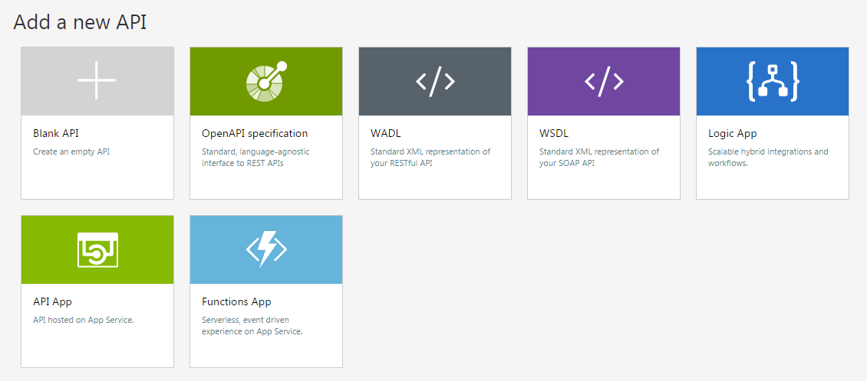

1. Select pgemailservice1 as function APP.

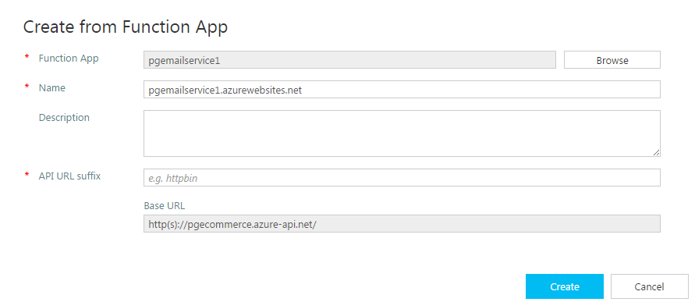

1. In the publisher portal -> APIs, select ‘Email Service’. Add the free trial as Product under ‘Product’ tab.

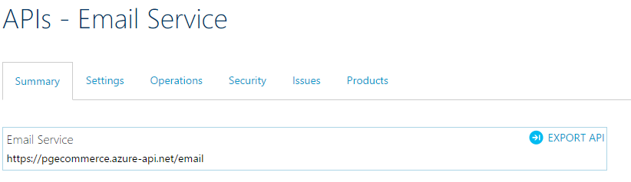

1. Test the API, Go to API Management landing page and select ‘Email Service’, enter the below input fields and click Send button.

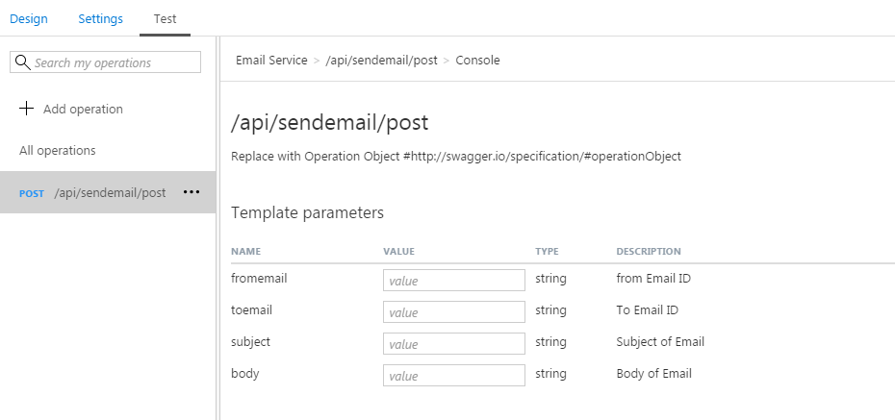

1. Below validated screen should come:

